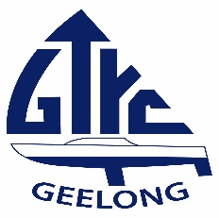 Geelong Trailable Yacht Club
Corio Bay Piles and Markers Co-ordinates
ST. HELENS
Start & Finish 38.07.088 S 144.21.621 E

CB LOCATIONS
CB 1. 38.05.558 S 144.24.201 E
CB 2. 38.07.616 S 144.24.181 E
CB 3. 38.08.457 S 144.22.879 E
CB 4. 38.08.525 S 144.22.140 E
CB 5. 38.06.236 S 144.22.767 E
CB 6. 38.06.484 S 144.24.200 E

WEST CARDINAL MARK
38.08.305 S 144.22.035 E

NORTH CHANNEL PILES
RED West Lead 38.05.757 S 144.24.767 E
RED East Lead 38.06.083 S 144.26.201 E

HOPTOUN CHANNEL PILES
No. 1 38.07.050 S 144.26.760 E
No. 3 38.07.120 S 144.26.140 E
No. 7 38.07.250 S 144.24.790 E

CORIO No. 5
38.06.210 S 144.22.680 E

SOUTH CHANNEL PILE
38.06.088 S 144.24.943 E

NINE FOOT CUT PILE
38.06.206 S 144.27.280 E

OUTER HARBOUR PILES AND MARKERS

Arthur The Great Steamboat Pile
Floating Yellow Buoy 38.06.680 S 144.30.981 E
38.04.573 S 144.33.130 E

Cluster Pile Curlewis Pile
38.08.131 S 144.30.112 E 38.08.238 S 144.26.627 E

